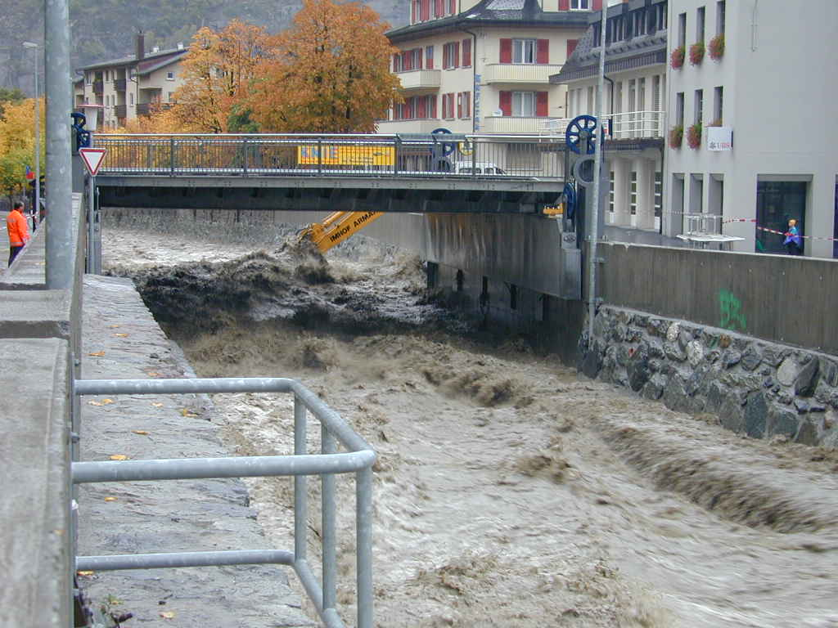

Winter excursion of the young geomorphologists (SGmS)

Hydrological hazard of Saltina torrent (Brig)

15 and 16 February 2019

Name:

Organization:

Address:

E-mail:

SGmS member (yes/no):

Swiss pass for train GA/halftax

Cost: The participation is free of charges for young geomorphologists members of the SGmS. 30.- CHF for non-SGmS members

Payment at: PC 80-46505-2
Schweizerische Geomorphologische Gesellschaft CH - 4912 Aarwangen
IBAN CH78 0900 0000 8004 6505 2
Please add «Winter excursion young geomorphologist 2019» in the comment section

Getting to Brig: Information on the SBB/CFF/FFS website (www.cﬀ.ch)

Contact: Elisa Giaccone, University of Lausanne, elisa.giaccone@unil.ch
Deadline: 11 January 2019, to Elisa Giaccone, elisa.giaccone@unil.ch

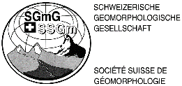
Kindly supported by:

