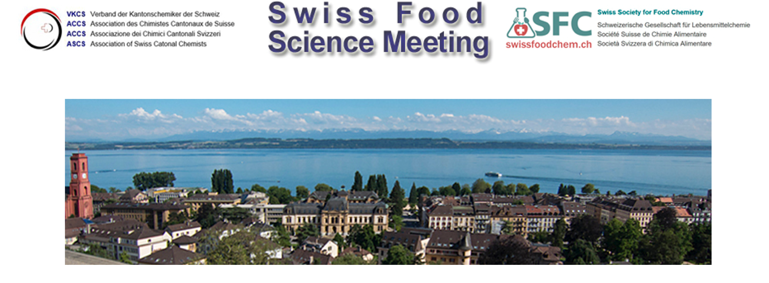

Abstract Submission Form (oral and poster presentations)

We invite participants to contribute oral and poster presentations during the meeting on topics related to food chemistry and food analytics (not limited to the meeting theme on future food and dietary supplements).

Oral presentations. Abstracts submitted by April 10th 2023 will be considered for oral presentation, and will be notified on possible selection by April 30th, 2023.

Poster session and short talks. The dedicated poster session during the meeting will be complemented with short oral presentations on the posters. The number of short oral presentations is limited. We wish our poster to be considered for a short oral presentation:
Yes No

Abstracts submitted by April 10th 2023 will be considered for short oral presentation, and will be notified on possible selection by April 30th, 2023. Last minute posters are accepted until May 31st.

Please return this form by mail to: Email: info@swissfoodchem.ch

Abstract max. 250 words. Make sure that the most important details of the methodology as well as main results or outcomes of the study are presented in the abstract.

Presenting Author
List of Authors
Institute/ Company
Address
Telephone
Email
Title of Presentation
Abstract
Introduction:

Methods:

Results and Discussion:

Conclusion and Outlook:

